# Chapter 1

# Synopsis

## Project Title

## “ServePlus – A System to Reduce Food Wastage”

## This is a Django-based web application designed to prevent food wastage by connecting individuals, restaurants, and organizations/NGO's with surplus food to those in need. The platform enables easy food donation, pickup coordination, and promotes sustainability.

## Internal Guide

## Prof. Kamble S.A.

## Project Co-Ordinator,

## CSE, BIT, Barshi

## Technical Keywords

## Food Wastage Prevention, Zero Waste Initiative, Food Donation Platform, zero waste Initiate, Django Web App.

## Problem Statement

## Food donors and NGOs lack coordination.

## Manual processes are time-consuming and ineffective.

## Need for a secure, centralized donation platform.

## Abstract

Food wastage is a major issue that affects both the environment and people who do not have enough to eat. This paper introduces ServePlus, a website that helps to reduce food waste by connecting people who have extra food with those who need it, such as NGO’s, hotels and community kitchens. This platform is built using Django and offers features like user login, food donation forms, pickup requests, and location-based services. It makes the food donation process easy, safe, and quick.

## Goals And Objectives

## Reduce food wastage.

## Provide a secure and efficient donation process.

## Connect donors with NGOs and volunteers in real-time.

## Names of Conferences / Journals where papers can be published

## National / International Conferences

## ACM COMPASS (Conference on Computing and Sustainable Societies)

## IEEE International Conference on Smart Technologies and Management for Computing, Communication, Controls, Energy and Materials (ICSTM)

## ICCCI (International Conference on Computational Intelligence & Communication)

## IEEE Global Humanitarian Technology Conference (GHTC)

* **Journals**

1. International Journal of Engineering and Technology (IJET)
2. International Journal of Computer Applications (IJCA)
3. International Journal of Sustainable Development & World Ecology.
4. International Journal of Advanced Research and Innovative Ideas in Education (IJARIIE).

## Review of Conference/Journal Papers supporting Project Idea

Food and Agriculture Organization (FAO), “The State of Food Security and Nutrition in the World,” United Nation, 2022 [Online]. Available: <https://www.fao.org>

Feeding India by Zomato, “Hunger Heroes,” [Online]. Available: <https://www.feedingindia.org>

J. Smith and R. Kumar, “Reducing Food Waste Through Donation App,” *International Journal of Sustainable Development*, vol 14, no. 3, pp. 110-115, 2021

Django Software Foundation, “Django Documentation,” [Online]. Available: <https://docs.djangoproject.com>

T. Johnson, “Role of Technology in Addressing Hunger Issue,” *Journal of Social Impact Technology*, vol. 8, no. 2, pp. 45-50, 2020

## Plan of Project Execution

1. **Planning:** The development of the ServePlus project was carried out in a structured and phased manner to ensure systematic implementation and delivery.
2. **Requirement Gathering**: Gathered and analyzed requirements related to food wastage, NGO coordinator, donor registration, and real-time food listing. Identified stakeholders 9donors, NGOs, admin) and their roles.
3. **System Design:** Designed the architecture of the system including database schema, user flow diagrams, and system components like donor module, NGO module, and admin dashboard.
4. **Backend Development:** Implemented REST APIs using Django and Django REST Framework. Created models, views, serializers, and custom user authentication (OTP Based). Integrated food listing, donation record, and user profile management.
5. **Frontend Development:** Developed user interfaces for web portal using HTML, CSS, JavaScript, and optionally React. Pages include donor registration/login, NGO Login, food listing form, and NGO dashboard.
6. **Integration and Testing: -** Integrated frontend with backend APIs. Conducted unit testing, system testing, and user acceptance testing to ensure reliability and functionality. Handled edge cases like expired food, user validation, etc.
7. **Deployment: -** Creation The project will be deployed on AWS EC2 instance. Configured domain setting, HTTP via SSL, and ensured 24*7 accessibility. Set up database on cloud or hosted SQLite instance.

# Chapter 2 Technical Keywords

## Area of Project

The are of the ServePlus project lies at the intersection of the following domains:

1. **Web Development:**

The project is developed as a full-stack web application using Django (python) for the backend and React JS for the frontend. It provides an interactive interface for users such as donors, NGOs, and administrators.

1. **Social Welfare Technology:**

ServePlus addresses real-world problems such as hunger and food wastage by connecting food donors (individuals/restaurants) with NGOs in need. It uses technology as a tool for social good.

1. **Database Management:**

The system uses a relational database (SQLite) for storing user data, food donation records, and transaction records, and transaction logs, it ensures data integrity and effective data retrieval.

# Chapter 3 Introduction

## Introduction

## Food wastage is one of the most serious yet often overlooked global problem. While millions of people go to bed hungry each night, large quantities of perfectly edible food are thrown away daily by households, restaurants, hotels, supermarkets, and event organizer. This food, if redirected, could help fight hunger, reduce environmental damage, and support community in need.

## This ServePlus is a web-based platform built using Django that helps to reduce food wastage by connecting people who have extra food with those in need. The goal of this project is to hungry or needy people nearby. Users can sign up as donors or receivers. Donors can post food details, and receivers or NGOs can request it. The system matches them based on location and availability. ServePlus promotes sustainable living, reduces food waste, and support communities through food sharing.

## The platform supports location-based matching, allowing donors and receivers to find each other easily. Donor can post available food details, set pickup time and location, and track the status of their donation. Receivers such as NGOs or individuals in need, can browse available food, send requests, and receive food without any middleman.

## By digitizing the food donation process, ServePlus encourages responsible behavior, promotes community well-being, and contributes to the border goals of sustainable development. It empowers people to be part of a movement that not only saves food but also brings dignity and hope to the lives of the hungry.

## This platform is designed with user-friendly features and clean interface to ensure that both tech-savvy users and those with limited digital experience can easily navigate it. With proper verification processes and real-time updates, ServePlus ensure that donation reach genuine recipients safely and efficiently.

* 1. **Project Idea and Motivation**

**Project Idea:**

ServePlus is a web-based platform designed to bridge the gap between food donors (such as restaurants, event organizers, households) and NGOs or organizations working to feed the needy. The platform enables donors to register and list surplus or leftover food, which is then visible to verified NGOs in real time. NGOs can claim the food based on location, quantity, and need, ensuring timely pickup and delivery to beneficiaries. The system includes user authentication, real-time food availability, and a user-friendly dashboard for both donors and NGOs.

**Motivation:**

In India and many parts of the world, food wastage remains a critical issue, even as millions of people go to bed hungry. Events, restaurants, and households often dispose of large quantities of edible food due to a lack of proper channels for redistribution. Observing this imbalance, the idea for ServePlus was born — to use technology as a tool to reduce food wastage and combat hunger. The motivation behind the project is both social and environmental, aiming to contribute to sustainable development while fostering a sense of community responsibility.

ServePlus is not just a technical solution but a social initiative powered by technology. It reflects a growing trend of using digital platforms to address global challenges through smart, efficient, and scalable solutions.

## Literature Survey

## Food wastage has emerged as a significant global concern, with both environmental and humanitarian consequences. According to the United Nations Environment Programmed (UNEP), approximately one-third of all food produced globally is wasted, despite millions suffering from hunger and malnutrition. This paradox has led to the development of several technological solutions aimed at redistributing surplus food to those in need.

## Existing platforms like Feeding India, Robin Hood Army, and Replate have made impactful strides in food donation. These organizations rely heavily on manual coordination and volunteers to collect and distribute food. While effective in their respective regions, many lack automation, real-time tracking, and tailored donor-recipient matching, which limits scalability and efficiency.

## Academic research has explored different models of food redistribution using mobile and web-based platforms. Some studies focus on logistics optimization using machine learning algorithms, while others discuss real-time inventory systems for perishable goods. A common limitation identified across these systems is the absence of user-centric interfaces and integration with hyper-local community data, which affects usability and local engagement.

## Moreover, many existing solutions either target large-scale institutional donors or operate at a non-digital grassroots level. There is a gap in platforms that enable individual households, local food businesses, and community kitchens to participate easily in food donation processes through a centralized digital system.

## In light of these gaps, the ServePlus platform is designed to bridge the divide between surplus food providers and needy recipients using a smart, accessible web application. It leverages user roles (donors, volunteers, NGOs), location-based matching, and real-time updates to create a more organized and transparent food donation ecosystem. This approach not only supports sustainable food management but also encourages community-driven social responsibility.

# Chapter 4

**Problem Definition and Scope**

## Problem Statement

## Despite the abundance of food in many urban areas, a significant portion of the population continues to suffer from hunger and malnutrition. Every day, large quantities of surplus or leftover food from households, restaurants, events, and canteens go to waste due to the absence of a structured system for redistribution. NGOs and charitable organizations that serve the needy often struggle to locate such food sources in time, leading to missed opportunities to feed the hungry.

## There is currently no efficient, centralized, and user-friendly platform that facilitates real-time communication and coordination between food donors and NGOs. Manual donation processes are unorganized, time-consuming, and prone to delays, resulting in both food wastage and unserved individuals.

## Therefore, there is a need for a digital solution that can bridge the gap between food donors and NGOs, enabling quick, transparent, and organized food donation processes.

## Goals and Objectives

## Project Goal:

## To develop a web-based platform that effectively connects food donors with NGOs, enabling timely redistribution of surplus food to reduce wastage and help feed the needy.

## Project Objectives:

## To build a user-friendly web application

## that allows individuals, restaurants, and event organizers to register and donate leftover food easily.

## To create a centralized platform

## where verified NGOs can view and claim food donations based on availability, location, and quantity.

## To implement a secure authentication system

## using OTP-based registration and login for both donors and NGOs to ensure safety and trust.

## To enable real-time food listing and updates

## so, NGOs can act quickly before the food perishes.

## To integrate an admin panel

## for monitoring user activity, managing NGOs/donors, and ensuring the legitimacy of food donations.

## To minimize food wastage

## by streamlining the donation process and raising awareness among donors.

## To deploy the platform online

## ensuring 24x7 availability via cloud hosting (AWS EC2).

## Application

## The ServePlus platform has a wide range of real-world applications, especially in the social and environmental sectors. Its main objective is to reduce food wastage while supporting organizations that serve the underprivileged.

## Applications:

## Restaurants and Hotels:

## Can list excess food at the end of the day, allowing NGOs to pick it up and distribute it to those in need.

## Event Organizers:

## Often left with large quantities of untouched food after events. ServePlus provides a simple way to donate this food quickly.

## Households and Individuals:

## Can contribute ServePlus home cooked food in a safe and controlled manner to nearby NGOs.

## NGOs and Charitable Organizations:

## Can use the platform to find food donations in real time and serve it to the homeless, orphanages, or disaster-affected areas.

## Hardware And Software Resources Required

## 4.4.1 Hardware Requirements:

|  |  |
| --- | --- |
| Component | Specification |
| Processor | Intel core i3 or above |
| RAM | Minimum 4 GB |
| Hard Disk | Minimum 10 GB free space |
| Network | Stable Internet connection (for deployment and testing) |
| Server (for deployment) | AWS EC2 instance (t2.micro or above) |

## 4.4.2 Software Requirements:

|  |  |
| --- | --- |
| Software | Purpose |
| Operating System | Windows 10 |
| Python (3.9 or above) | Backend development using Django |
| React JS | Frontend Development |
| SQLite | Database Management |
| VS Code | Code Editor |
| Git & GitHub | Version control & code collaboration |
| Postman | API Testing |
| AWS EC2 | For cloud deployment |
| Browser | Web interface testing. |

# Chapter 5 Project Plan

The development of the **ServePlus** project was structured into well-defined phases to ensure organized progress, timely completion, and quality output. The project followed a **phased and iterative development model**, ensuring feedback-based improvements at every step.

## Project Estimates

Figure 5.1: Plan of execution

#### Requirement Gathering and analysis:

Identify key stakeholders (donors, NGOs, admin), understand food donation process, and define system requirements.

#### System Design:

The requirement specifications from first phase are studied in this phase and the system design is prepared. This system design helps in specifying hardware and system requirements and helps in defining the overall system architecture.

#### Implementation:

With inputs from the system design, the system is first developed in small programs called units, which are integrated in the next phase. Each unit is developed and tested for its functionality, which is referred to as Unit Testing.

#### Integration and Testing:

All the units developed in the implementation phase are integrated into a system after testing of each unit. Post integration the entire system is tested for any faults and failures.

#### Deployment of system:

Once the functional and non-functional testing is done; the product is deployed in the customer environment or released into the market.

#### Maintenance:

There are some issues which come up in the client environment. To fix those issues, patches are released. Also to enhance the product some better versions are released. Maintenance is done to deliver these changes in the customer environment.

## Project Resource

## Developers – 2

Testers -2

Eclipse Editor

At least 2 laptops with Windows OS

Internet connection

Java Debugging tools)

## RISK MANAGEMENTW.R.T. NP HARD ANALYSIS

In computer science, **NP-Hard problems** are those for which no known polynomial-time algorithm exists. These problems are computationally intensive and become increasingly difficult to solve as input size grows. Although ServePlus is a web-based platform and doesn't directly implement classical NP-Hard algorithms (like the Traveling Salesman Problem or Knapsack Problem), certain functionalities may involve **NP-Hard-like challenges**, particularly in **resource optimization and dynamic matching**.

### Risk Identification

In the development of any software system, identifying potential risks early helps mitigate their impact. For the **ServePlus** project, the following key risk areas were identified and evaluated based on their potential **impact on project success**:

| **Risk Factor** | **Description** | **Impact Value (Low/Medium/High)** | **Mitigation Strategy** |
| --- | --- | --- | --- |
| 1. Domain Knowledge | Limited understanding of real-world food donation logistics may lead to impractical features or poor user experience. | Medium | Conduct secondary research, study existing food donation platforms, and consult NGOs or restaurant managers. |
| 2. Technology will not Meet Expectations | Chosen tech stack (Django, React, AWS) may not scale well under real-world load or feature requirements. | Medium | Perform stress testing, optimize APIs, and use proven frameworks and cloud tools. |
| 3. Lack of Development Experience | The development team may face delays or bugs due to limited experience with full-stack development and cloud deployment. | High | Follow official documentation, break tasks into smaller parts, and use mentorship/online tutorials. |
| 4. Quality Documentation | Lack of clear documentation may hinder future maintenance and onboarding of new developers. | Medium | Maintain structured code comments, README files, and final technical documentation. |
| 5. Deviation from Software Engineering Standards | Not following proper design, coding, or testing practices may lead to low-quality software. | High | Use version control (Git), follow MVC architecture, and conduct regular code reviews. |
| 6. Poor Comments in Code | Code without proper commenting reduces maintainability and scalability. | Low | Enforce a standard commenting format and write self-explanatory functions. |
| 7. Changes in Requirements | Late-stage changes requested by users or mentors may disrupt timelines and code stability. | High | Use Agile/iterative development to adapt to changes, keep code modular, and set a freeze date for major changes. |

### Risk Analysis

Risk analysis involves evaluating identified risks based on likelihood of occurrence and impact on the project. This helps in prioritizing which risks require more attention and proactive mitigation.

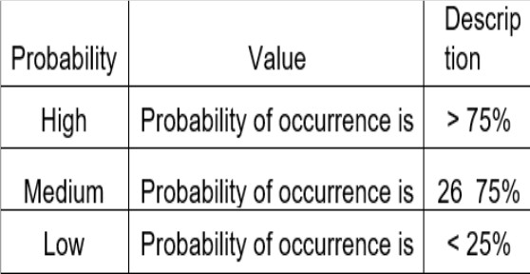

Figure 5.3: Risk Analysis

# Chapter 6

**Software requirement specification**

## Introduction

### Purpose and Scope of Document

### Purpose:

### The purpose of this Software Requirement Specification (SRS) document is to define the functional and non-functional requirements of the ServePlus system — a web-based food donation platform. This document serves as a guideline for all stakeholders including developers, testers, project managers, and end-users, ensuring a mutual understanding of system expectations.

### The SRS outlines the system's objectives, features, user interfaces, constraints, and data handling processes. It also provides a foundation for system design, development, testing, and maintenance.

### Key Purpose:

### To clearly describe the functionality of the ServePlus system.

### To act as a reference throughout the software development lifecycle (SDLC).

### To identify constraints, assumptions, and dependencies.

* To minimize misunderstandings between users and developers.

**Scope:**

The **ServePlus** platform connects **food donors** (individuals, restaurants, canteens, event organizers) with **NGOs** and charitable organizations that distribute food to the needy. The system allows users to register, post available surplus food, and view donations in real time. NGOs can browse listings based on location and need, and claim food for pickup.

The platform will include:

* User registration and OTP-based login (Donors & NGOs).
* Real-time food donation listing.
* NGO dashboard for managing pickups.
* Admin panel for system monitoring and user management.
* Notification system for updates and confirmations.
* Cloud deployment with online accessibility.

### Overview of Responsibilities of Developer

The development team plays a critical role in transforming the requirements of the **ServePlus** project into a functional, scalable, and user-friendly software solution. The responsibilities of the developer(s) include the complete lifecycle of software development — from initial design and coding to testing, deployment, and maintenance.

**Key Responsibilities:**

* + - 1. Requirement Understanding.
      2. System Design.
      3. Frontend Development.
      4. Backend Development.
      5. Database Management.
      6. Testing and debugging.
      7. Deployment and Hosting.
      8. Documentation.
      9. Version Control.

## To test the code USAGE SCENARIO

The purpose of this section is to define real-world **usage scenarios** that simulate how the users (Donor, NGO, and Admin) will interact with the ServePlus system. These scenarios are used to verify that the application meets its functional requirements and behaves correctly in different workflows.

### Use-cases Diagram:

Use case diagram for satisfying above conditions is constructed. Refer given Diagram which gives thorough explanation of use cases in this project.

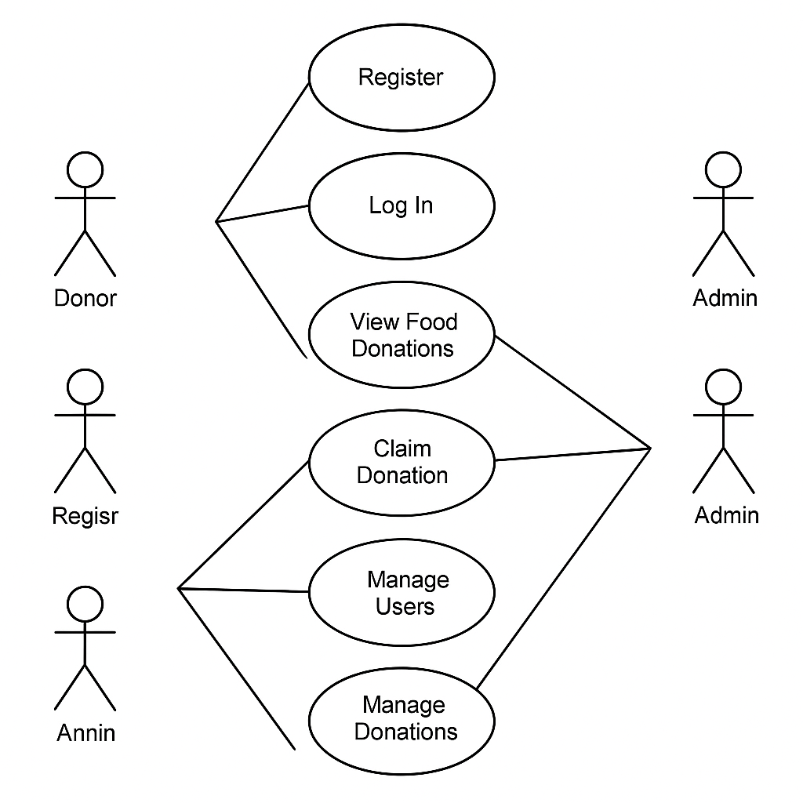

Fig. 6.2.1 Use Case Dig

## Data Model and Description

### Data Description

We will be using SQLite database to save users credentials. The data model defines the structure of the database used in the **ServePlus** system. It includes **entities (tables)**, their **attributes (fields)**, and **relationships**. This model supports the core functionality such as user management, food donations, claims, and admin operations.

1. **User (Custom User):**

| **Field** | **Description** |
| --- | --- |
| id | Primary key (auto-increment) |
| email | Unique email/username |
| phone | Phone number |
| is_donor | Boolean (True if Donor) |
| is_ngo | Boolean (True if NGO) |
| is_admin | Boolean (True if Admin) |
| date_joined | Date of account creation |
| otp_verified | Boolean to track OTP login |

Fig. 6.3.1. User

1. **Food Donation:**

| **Field** | **Description** |
| --- | --- |
| id | Primary key |
| donor_id | Foreign key to User |
| food_type | Type/category of food |
| quantity | Quantity (e.g., number of people fed) |
| location | Pickup address |
| expiry_time | Food valid till |
| status | Available / Claimed / Expired |
| timestamp | Date and time of listing |

Fig. 6.3.2. Food Donation

1. **NGO Claim:**

| **Field** | **Description** |
| --- | --- |
| id | Primary key |
| ngo_id | Foreign key to User (NGO) |
| food_id | Foreign key to Food Donation |
| claim_time | Timestamp when claim was made |
| pickup_time | Scheduled pickup time |

Fig. 6.3.3. NGO Claim

1. **Admin Activity:**

| **Field** | **Description** |
| --- | --- |
| id | Primary key |
| admin_id | Foreign key to User (Admin) |
| action_type | Action (e.g., delete user, flag food) |
| target_user_id | User involved in the action |
| timestamp | Date and time of action |

Fig. 6.3.4. Admin Activity

## Functional Model and Description

## 

## The Functional Model defines how the ServePlus system behaves in response to user actions and outlines the major functionalities provided to different user types (Donor, NGO, Admin). It helps in understanding the interaction between the user and the system in terms of services provided.

| **Module Name** | **Description** |
| --- | --- |
| User Registration & Login | Allows users (Donors/NGOs/Admins) to register using email or phone and log in with OTP verification. |
| Food Listing (Donor) | Donors can list surplus food with details like quantity, type, location, and expiry time. |
| Food Browsing (NGO) | NGOs can browse available food listings and filter them by location or food type. |
| Food Claiming (NGO) | NGOs can claim food donations and schedule pickup times. |
| Admin Management | Admin can view all users, monitor donations, delete spam entries, and manage system integrity. |
| Notifications | Real-time notifications are sent to users on successful listing, claim, pickup, or expiry. |
| Food Expiry Handling | System automatically marks food as expired once the expiry time has passed without being claimed. |

Figure 6.4: Major Functional Models

### Data Flow Diagram

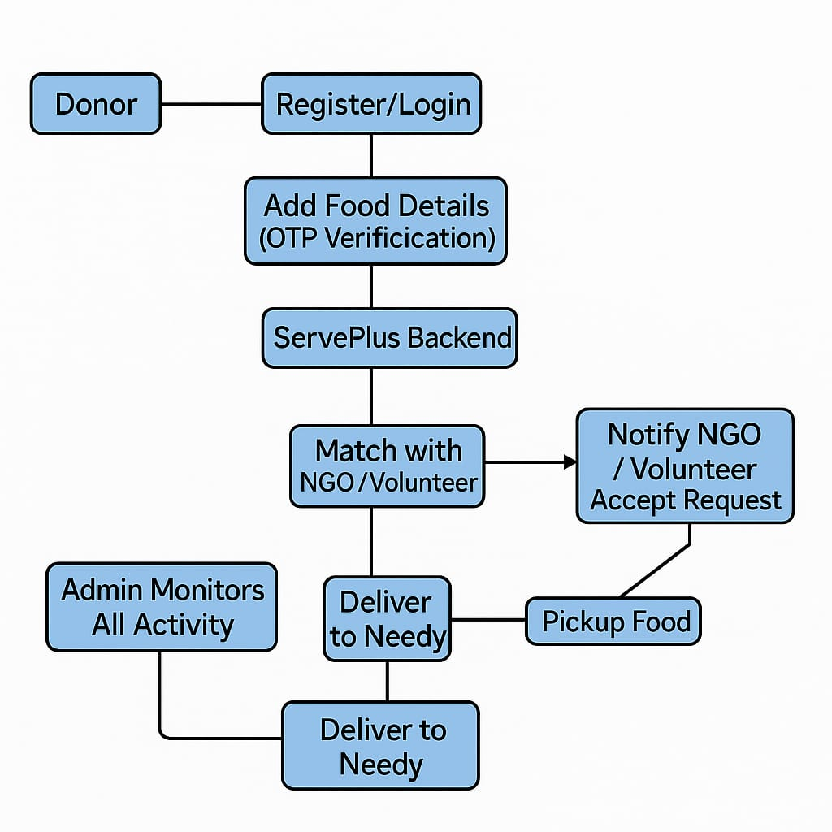

Figure 6.4.1. Data Flow Diagram

# Chapter 7 SYSTEM DESIGN

## Introduction

## 

## The System Design phase is crucial in transforming the gathered requirements into a structured blueprint that guides the actual implementation of the project. For the ServePlus platform, system design outlines how different components interact, how data flows through the system, and how user functionalities are organized.

## ServePlus is designed using the modular approach, with clear separation between frontend, backend, and database layers. This ensures scalability, maintainability, and security. The system follows a three-tier architecture:

## Presentation Layer (Frontend – React JS)

## Application Layer (Backend Logic – Django)

## Data Layer (Database – SQLite)

## Architectural Design

## The ServePlus platform follows a Three-Tier Architecture model that separates the application into three distinct layers: Presentation Layer, Application Layer, and Data Layer. This architecture ensures modularity, scalability, and maintainability.

## 

Figure 7.2: Architectural Design

# Chapter 8

**CONCLUSION AND FUTURE SCOPE**

## Conclusion

#### Conclusion:

#### 

#### ServePlus is a meaningful step toward solving the common yet serious problem of food wastage. Every day, large amounts of edible food are thrown away while many people go hungry. ServePlus bridges this gap by providing a digital platform where individuals or organizations can donate excess food and others in need can receive it. The system ensures that the donation process is smooth, organized, and transparent.

#### By using technologies like Django, HTML, CSS, Bootstrap, and ReactJS, ServePlus creates an easy-to-use web platform that works well across different devices. It allows donors to share food details quickly, and receivers to find and request food based on their availability and location. The inclusion of an admin role helps manage and monitors all activities to maintain the reliability and safety of the platform.

#### In conclusion, ServePlus is not just a technical project but a socially impactful initiative. It has the potential to grow and serve more people by reducing food waste, prompt sharing, and supporting those who are in need. With further development and public involvement, ServePlus can become a strong tool for creating a more sustainable and caring society.

## Future Scope

#### Future Scope:

#### Although ServePlus works well in its current form, there are several ways it can be improved in the future. One of the most useful additions would be a mobile application for Android and iOS. This would allow users to donate or request food directly from their smartphones, making the process faster and more convenient.

#### Another improvement could be adding a location-based matching system using Google Maps or GPS. This would help receivers find donations that are physically close to them, reducing travel time and ensuring that food is picked up before it spoils.

#### We also plan to add features like notifications and alerts, so donors and receivers can get real-time updates on donation status. Adding multiple language support would help many users to understand and use the platform, especially in rural or regional areas.

#### We may also integrate AI tools in the future to predict demand and suggest efficient donation strategies. All these enhancements will make ServePlus more powerful, user-friendly, and impactful.

**9. References**

1. Food and Agriculture Organization (FAO), “The State of Food Security and Nutrition in the World,” United Nation, 2022 [Online]. Available: <https://www.fao.org>
2. Feeding India by Zomato, “Hunger Heroes,” [Online]. Available: <https://www.feedingindia.org>
3. J. Smith and R. Kumar, “Reducing Food Waste Through Donation App,” *International Journal of Sustainable Development*, vol 14, no. 3, pp. 110-115, 2021
4. Django Software Foundation, “Django Documentation,” [Online]. Available: <https://docs.djangoproject.com>
5. T. Johnson, “Role of Technology in Addressing Hunger Issue,” *Journal of Social Impact Technology*, vol. 8, no. 2, pp. 45-50, 2020